INTRODUCTION TO
HUMAN-CENTERED DESIGN
Course Project
Instructions:
In this project, you will:
- Formulate an innovative concept for an interactive technology to meet human needs
- Distinguish between good and bad design
- Evaluate usability and user experience
- Ideate a project to apply the human-centered design process
- Prepare a list of ethical considerations when interacting with your user group
Except as indicated, use this document to record all your project work and responses to any questions. At a minimum, you will need to turn in a digital copy of this document to your instructor as part of your project completion. You may also have additional supporting documents that you will need to submit. Your instructor will provide feedback to help you work through your findings
Note: Though your work will only be seen by those grading the course and will not be used or shared outside the course, you should take care to obscure any information you feel might be of a sensitive or confidential nature.
Complete each project part as you progress through the course. Wait to submit the project until all parts are complete. Begin your course project by completing Part One below. A Submit Assignment button can be found on the final course project assignment page online. Information about the grading rubric is available on any of the course project assignment pages online. Do not hesitate to contact your instructor if you have any questions about the project.

Formulate an Innovative Concept for
an Interactive Technology to Meet Human Needs
___________________________________________________________________
This module introduced human-computer interaction (HCI) and the interactions between people and technologies at a broad level. Designing technologies involves a balance between understanding human experiences on the one hand and offering an innovative solution that responds to these experiences on the other.

To complete this part of the project, you will need to think of an experience that you recently had that might have been improved with interactive technology. You will then need to conceptualize a novel interactive technology that responds to this experience, then assess potential implications and consequences of the technology beyond responding to your experience.

- What is the experience? In what context did it take place? Who else was involved?

IDEA #1:
My family and I have two dogs; and my four daughters and I have thick hair falling between mid-back and waist level. This creates a hairy situation in need of a vacuum cleaner that can handle it! For over 15 years, we have been forced to purchase a new vacuum cleaner at least once a year, sometimes twice in one year, and none of them, ranging from low-end to high-end and including various “pet vacuums” have been able to cut it. I often hear other woman, mothers, and pet-owners voice similar complaints and need. Despite their claims, current vacuum cleaner models are unable to withstand large amounts of pet and human hair, especially long and/or thick hair. They either will not vacuum the hair at all, and it can stick to and build up in the carpet, or if they are able to suction the hair, the hair easily becomes tangled around the brushes or clogs the hoses and will quickly make the vacuum inoperable.

IDEA #2:
Problems with TV/streaming device remote controls drive many people crazy, myself included, as well as a number of my friends and family members. For starters, there are seven televisions/streaming devices in my family’s home, requiring seven remote controls. Each of these remotes are identical and are exceedingly small. Having seven remotes calls for a lot of batteries too!
I know in the past remote controls were large and overloaded with buttons, most of which made use complicated, and the buttons were not needed. The design of remote controls in general have greatly improved and have decreased the buttons mainly to those needed by the user: the power button, channel buttons, and volume buttons. However, with a huge decrease in the number of buttons came a decrease in the size of the remote control itself.
This has created new problems which my family and I are experiencing. Having several identical looking remote controls leads to easily getting them mixed up. Additionally, small remote controls constantly end up lost or misplaced. Also, it is high time for remote controls to become battery free, especially since, accordingly to coursehero.com, “The average American home has four televisions” (2021). We have long had electric chargers, but this technology has failed to cross over to remote controls. Now we have wireless docking stations for charging devices. Plain and simple, remote-control technology needs to catch up to the needs of modern everyday users!

- What is a problem or human need encapsulated in this experience?

IDEA #1:
All homeowners, housekeepers, caregivers, and pet lovers finding themselves in a hairy situation need a vacuum cleaner that can handle large amounts of pet and human hair, especially long and/or thick hair, in order to prevent frustration, provide cost saving measures, and convenience from constantly needing to clean/remove hair from the vacuum and its parts and accessories, having to repair the vacuum frequently, and having to buy a new vacuum cleaner much more often than should be necessary.

IDEA #2:
TV viewers need to have their remote control easily accessible and available, and in operating order, whenever they want to watch or control their TV/streaming device and know that it is the correct remote control in order to prevent frustration and having to needlessly search for the remote and/or constantly replace batteries.

- What interactive technology did you think of that responds to this experience and could potentially address the problem/need?

IDEA #1:
Innovative technologies that could potentially address this problem/need: 1) Putting a higher-powered motor in the vacuum cleaner to create greater suction and functionality; 2) Creating self-cleaning hoses with high powered suction; 3) Include a separate small, but high-powered, vacuum-for-your-vacuum, specifically designed to clean/unclog the hoses and accessories; 4) Include safe hair eating technology in the vacuum, such as a safety razor that can actually cut, shear, or grind up the hair, so it can easily pass through the vacuum and its parts.

IDEA #2:
Innovative technologies that could potentially address this problem/need: 1) Reverting to a larger remote-control design; 2) Incorporating a sensor/tracking device with a find-remote signal or sound that can be activated when needed; 3) Having a remote-control stand/cradle/ wireless charger that comes with the remote and is designed especially for the remote and could potentially signal for a missing remote control; 4) A choice of various colors for the remote control; 5) The remote control could potentially be paired with smart phones, smart watches, and assistive devices, such as Echo, Google Assistant, and Cortana which would allow these devices to control the TV/streaming device instead of the remote-control if the user chooses.

- How does your idea address the problem/need in the experience you described?

IDEA #1:
My idea addresses the problem/need in the experience I described by providing four innovative technologies that could potentially provide a valid resolution: 1) Putting a higher-powered motor in the vacuum cleaner to create greater suction and functionality; 2) Creating self-cleaning hoses with high powered suction; 3) Include a separate small, but high-powered, vacuum-for-your-vacuum, specifically designed to clean/unclog the hoses and accessories; 4) Include safe hair eating technology in the vacuum, such as a safety razor that can actually cut, shear, or grind up the hair, so it can easily pass through the vacuum and its parts

IDEA #2:
My idea addresses the problem/need in the experience I described by providing five innovative technologies that could potentially provide a valid resolution: 1) Reverting to a larger remote-control design for greater visibility and allowing for decreased odds of losing or misplacing the remote ; 2) Incorporating a sensor/tracking device with a find-remote signal or sound that can be activated when needed, allowing the user to easily and quickly find the remote; 3) Having a remote-control stand/cradle/ wireless charger that comes with the remote and is designed especially for the remote, and could potentially have a button which would signal a sensor for a missing remote control, would provide a designated house for the remote-control, preventing loss; and it would also eliminate the need for batteries; 4) A choice of various colors for the remote control would potentially allow the user to choose different color remotes for each TV/streaming device in their home, altogether eliminating confusion over which remote belongs to which TV/streaming device (for example, the living room remote could be white, the office remote black, and the bedroom remote blue); 5) The remote control could potentially be paired with smart phones, smart watches, and assistive devices, such as Echo, Google Assistant, and Cortana which would allow these voice activated AI devices to control the TV/streaming device instead of the remote-control if the user chooses, providing greater convenience, efficiency, and ease of use.

- What makes your idea innovative compared to existing solutions? (Do some research to ensure that this technology doesn’t already exist.)

IDEA #1:
There are many vacuums that claim to be able to handle pet hair. “Pet vacuums" typically come with a higher price tag than non-pet-vacuums and are bulkier and heavier; and they do not address the need to handle large amounts of pet and/or human hair, especially long and/or thick hair. Even at the additional cost, bulk, and weight, hair becomes easily tangled in the brushes and the hoses become clogged. Thus, frequent cleaning, repairs, and purchases become necessary.
There are also professional cleaning services with industrial equipment that could be hired to deal with hairy situations. However, professional cleaning services with industrial equipment is not a viable solution for everyday use and may not be economically feasible for many people. What makes this technology novel compared to existing technologies is that it is designed specifically to deal with large amounts of pet and human hair, especially long and/or thick hair in new ways that have not previously been tried.

IDEA #2:
In doing some research, I found that similar tracking signals do exist for certain brands of remote controls. However, my idea is to include each of the aforementioned innovative technologies in a single remote-control which makes for a novel idea. Additionally, most remote controls only come in black, so offering various colors, much how we can choose the color of our cell phones, is a new and needed idea. Furthermore, allowing for the remote control to be paired with smart phones, smart watches, and assistive devices, such as Echo, Google Assistant, and Cortana which would allow these devices to control the TV/streaming device instead of the remote-control is a fairly innovative concept. The most novel of my five innovative technologies is having a charger, preferably a wireless docking station, for the remote charger. However, again, my idea is for each of these technologies to be included in one remote, allowing for a truly innovative interactive technology which could potentially altogether eliminate the discussed problems/need with remote controls.
.
- Think critically and describe any consequences of your invention: potentially new experiences and uses that would unfold; ethical, social, organizational, technological, legal, or policy implications related to your invention.

IDEA #1:
Safety is a major concern with my invention. A higher-powered motor, increased suction, and hair-cutting technology could present a danger to the user, if not used as indicated; and if altered or changed, could lead to damage of property, such as carpet, rugs, and furniture. The technology would have to be created in a safe way and may require a safety warning, especially since users have become so accustomed to removing their vacuum's parts and pieces in order perform cleaning and repairs. Additionally, the potential exists for a product that is already typically bulky and heavy to become even more bulky and heavy which is undesirable. It would have to be designed and manufactured with light-weight parts and pieces where applicable to prevent this unwanted consequence. Since the vacuum would consist of new technologies, the price could be higher than desired as well; and marketing of the product could be a concern too.
IDEA #2:
If the remote-control has a listening device and/or a tracking device, there could be ethical, legal, and policy implications regarding when and how the device is “listening” and privacy protections, and making the user aware. There could also be organizational, social, technological, and policy implications regarding consumer data storage and usage and user persona/profile information and how it is used and protected.

PART TWO
Distinguish Between Good and Bad Design
___________________________________________________________________
You examined the interdisciplinary approach that HCI uses to place and keep the user at the center of the design process. While designing is not as simple as following a checklist, there are some guidelines we can use to help determine whether the design has a positive or negative impact on the overall user experience. In order to understand whether a product is well designed or poorly designed, we identify the user of this product, the scenario in which they are using the product, the features of the user interface with which they interact, and whether these features provide a positive or a negative experience for the user toward achieving their goal.

To complete this part of the project, identify two interfaces: one illustrating good design and one illustrating bad design.

GOOD DESIGN

Share an example of good design.  (You are encouraged to provide visual evidence while also describing the details surrounding this design.) | 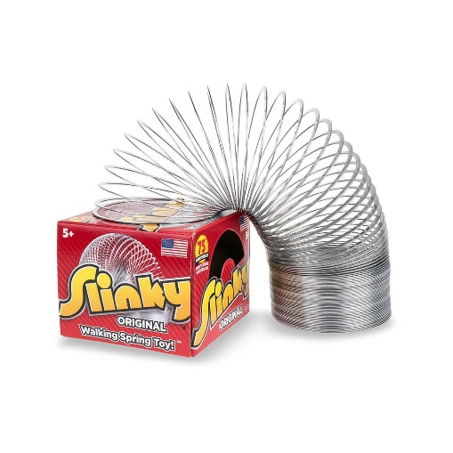  EXAMPLE 1:  Classic children’s toy: Slinky—“A Walking Spring Toy”  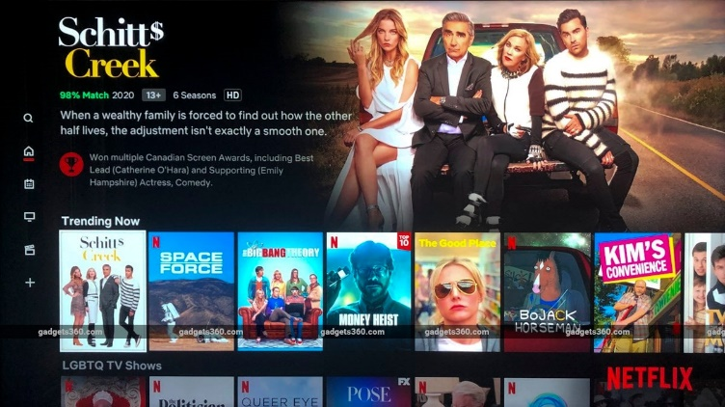  EXAMPLE 2:  Netflix UI
Identify the intended user(s): | EXAMPLE 1:  Slinky:  Age 5+ through Adult  EXAMPLE 2:  Netflix UI  Netflix account holders and users
Describe the use scenario: | EXAMPLE 1:  Slinky  The Slinky is a “walking spring toy” designed to entertain children via active play by walking down steps or stairs.  EXAMPLE 2:  Netflix UI  Netflix’s interface is used by Netflix account holders and users to search, browse, save favorites, and rate watchable content with Netflix’s database.
Outline the key design features of  the interface: | EXAMPLE 1:  Slinky  The key design feature of the Slinky interface is a simple a metal (or plastic) spring made up of oscillating spirals and is intended to be toppled over itself thus triggering it to “walk” down steps or stairs.  EXAMPLE 2:  Netflix UI  The key design features of Netflix user interface are: Allowability for creation of individual profiles; Various genres of shows and films specified by titles, such as “Trending Now”, “My List”, and “Comedies”, organized in rows which can be scrolled through; clickable icons running vertically down the far left-hand side of the screen, including home, search, and settings buttons; and a high-contrast design and easy to read fonts.
Assess and articulate why this is  a good design: | EXAMPLE 1:  Slinky  The slinky is a simple design that has offered positive, pleasurable, and joyful experiences to the generations and has sold over 400 million worldwide. The goal of the slinky is met efficiently by the user. The design and basic instructions imply to the user how the toy is to be used. Additionally, the design responds to user actions in an expected, predictable, and systematic way. Furthermore, the design matches the user’s mindset and background. Thus, the Slinky is a good design.  EXAMPLE 2:  Netflix UI  Netflix’s UI design is simple, effective, and efficient for the user. The features easily signal the user how the application is to be used, for example, the search function is represented by a large magnifying glass in an easy to see location. The UI also features high-contrast design and easy to read fonts. Additionally, the design responds to user actions in an expected, predictable, and systematic way. Furthermore, the design and features align with the user’s background and mindset. Hence, Netflix’s UI is a good design.

BAD DESIGN

Share an example of bad design.  (You are encouraged to provide visual evidence while also describing the details surrounding this design.) | 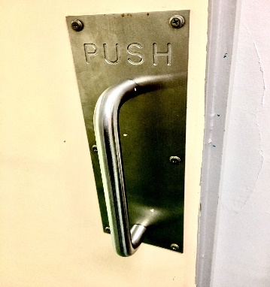  EXAMPLE 1:  Door with handle that must be pushed.  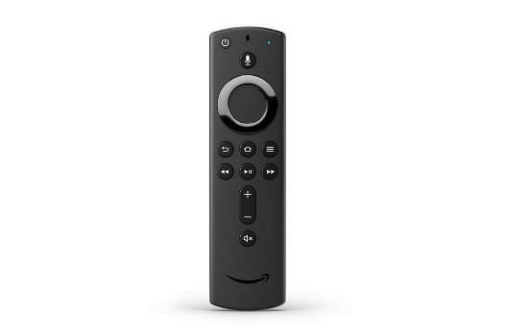  EXAMPLE 2:  Amazon Fire TV Cube Remote
Identify the intended user(s): | EXAMPLE 1:  PUSH Door Handle  The intended user is anybody entering into the Physician’s office at this medical clinic.  EXAMPLE 2:  Amazon Fire TV Cube Remote  The intended user is owners/users of the Amazon Fire TV Cube
Describe the use scenario: | EXAMPLE 1:  PUSH Door Handle  This is a door at a medical clinic. In order for the user to enter through this door, it must be pushed open.  EXAMPLE 2:  Amazon Fire TV Cube Remote  The remote is meant to be used for effective and efficient communication with the Amazon Fire TV Cube via the push of a few basic buttons as well as voice command via an audio button.
Outline the key design features of  the interface: | EXAMPLE 1:  PUSH Door Handle  There is a metal plate labeled “PUSH”. Even without the word label, the metal plate naturally signals to the user that the door should be pushed. The problem is that there is a metal handle attached to the metal plate, and a handle naturally signals the user to pull.  EXAMPLE 2:  Amazon Fire TV Cube Remote  The remote control is small, solid black and has matching black buttons covering the front panel (power, menu, home, play, fast forward, rewind, volume up/down, channel up/down, audio) and has a battery compartment (2 AAA) on the back panel; and it communicates effectively and efficiently, via use of the buttons between the streaming device and remote control. The remote also allows for voice command via the push of an audio button.
Assess and articulate why this is  a bad design: | EXAMPLE 1:  PUSH Door Handle  This is a bad design, because the handle naturally signals the user to pull when the door actually needs to be pushed. It is confusing and if it were a good design, it would not need a label or further instructions.  EXAMPLE 2:  Amazon Fire TV Cube Remote  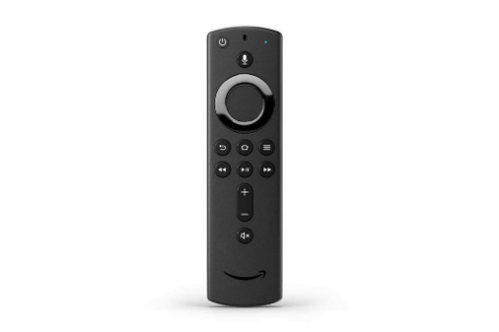  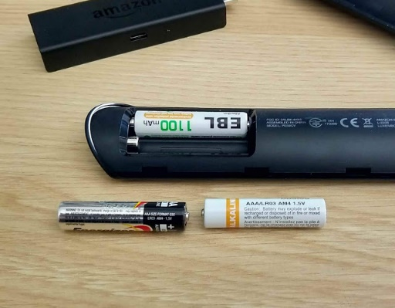  This is a bad design for a several reasons: 1) Due to the small design, the remote is easily lost or misplaced. 2) The buttons are the same color black as the remote itself, making them hard to see, particularly in dim lighting or at night. 3) There are no lights or light up buttons on the remote. 4) The “home” button is located directly above the “Play/pause” button and the two buttons nearly touch one another, causing the user to accidently hit the home key when attempting to pause or play. This is frustrating for the user, because it causes them to lose whatever show/film they were viewing and consequently have to find it again from the home page. 5) The remote only comes in black Fire TV Cube. Thus, if the user has multiple devices, they will have several identical looking remotes. 6) The audio isn’t very intuitive and only accurately picks up what is being said about half the time. 7) Additionally, the audio fails to work for prompts requiring a typed entry, such as usernames and passwords. 8) The remote requires 2 AAA batteries that require frequent changing.

PART THREE
Evaluate Usability and User Experience
___________________________________________________________________
This project will give you an opportunity to think more about usability and the user experience.

Choose a pointing device (touchpad, touchscreen, mouse, stylus, etc.) that you have access to and analyze the usability and user experience of interacting with the pointing device based on two sets of criteria.

Before you start, you may want to play a bit with the pointing device you have chosen, if you have one available. If you don’t have access to this pointing device, go online and search for descriptions and pictures of this device; learn about how to use this device, how it works, and how it manipulates user interface objects.

PART THREE (A): Choose the Pointing Device

1 | THE DEVICE | Samsung Galaxy Note 20 Ultra Stylus Feature: S Pen  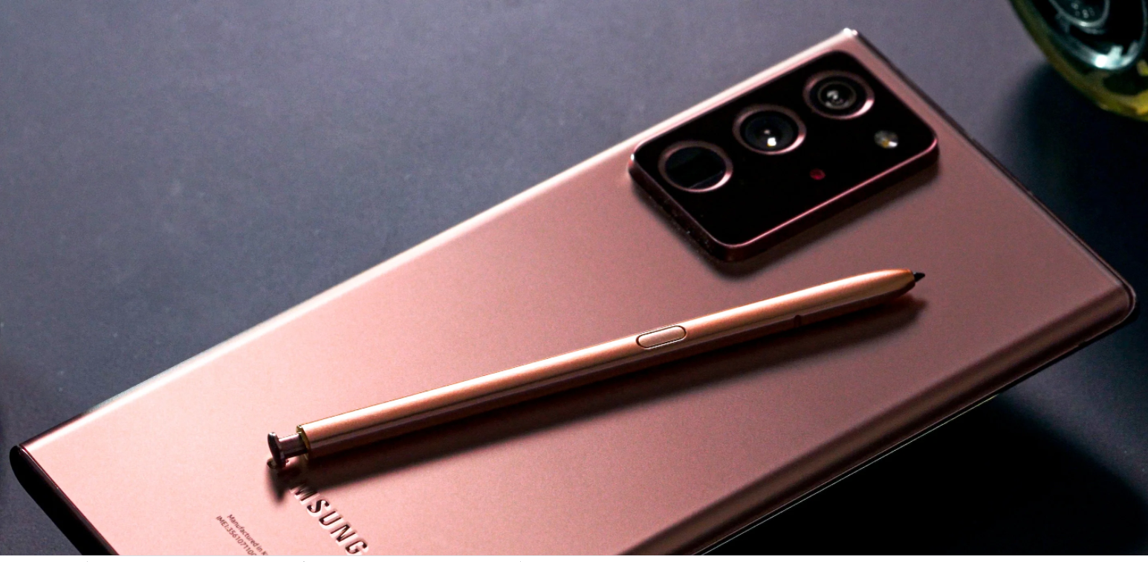
2 | HOW IT WORKS |   The S Pen is a physical stylus, with its own rechargeable battery, housed in a slot which is located on the bottom left of the Note 20 Ultra, and once popped out with a simple push, the stylus uses bluetooth to communicate with a chip in the phone, eliminating the need for the stylus to touch the phone to work. No pairing is required either. Additionally, the phone has software which alerts the user when the stylus is too far away from the phone.
3 | HOW ONE USES IT |   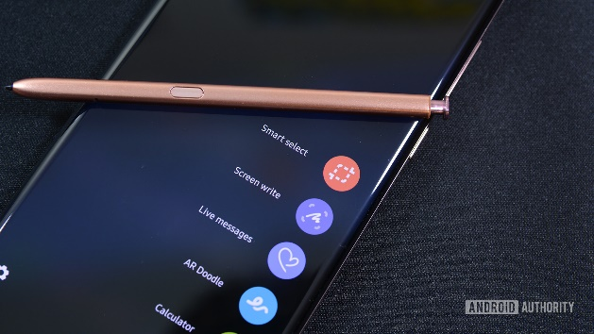  The most rudimentary function of the S Pen is to write digitally in Samsung Note, thus using the stylus like a pen and paper. It can also be used for scrolling, pointing/clicking, and interacting with apps. On a more complex level, “Anywhere Actions” are connected to gestures, so they can be used anytime.
4 | HOW IT IS USED TO MANIPULATE USER INTERFACE OBJECTS | A new feature of the S Pen is "Anywhere Actions" which allows the user to write in the air to control the Ultra, much like a magic wand. Some are linked to navigation controls by default, but others can be changed to user preference. Hence, various shortcuts and actions can be mapped to set gestures of choice. For instance, you can snap a photo with one click of the button.  The S Pen can be used for scrolling, pointing/clicking, and interacting with apps. However, it is more complicated than simply using your finger on the touchscreen for scrolling or pointing/clicking. Multiple steps are required, forcing the user to first become knowledgeable of these steps when the action could instead be designed in a way that would allow for intuitive single-step actions.

PART THREE (B): Assess the Usability of the Pointing Device

USABILITY METRICS | GUIDING QUESTION | HOW DOES THE POINTING DEVICE FARE  ON THIS METRIC?
Effectiveness | To what degree can a user successfully manipulate UI objects when using this pointing device? | The S Pen is effective at meeting most of its goals. However, the “Anywhere Actions” seem to respond accurately to assigned gestures only about 50% of the time. Nevertheless, it is highly innovative for a stylus and has many great features putting it at the top of the market.
Efficiency | How quickly can a user manipulate UI objects when using this pointing device? | The Ultra responds very quickly to the stylus, 9ms according to Samsung, with no noticeable lag time from when you begin penning in Samsung Note and strokes appear on-screen. The S Pen also responds almost instantly to “Anywhere Action” gestures as well.  It is inefficient to use the S Pen for scrolling and pointing/clicking, because it is more complicated and less efficient than simply using your finger on the touchscreen for scrolling or pointing/clicking. A step requiring the user to switch from keyboard to stylus is required. Thus, the user must first become knowledgeable of this step and take the required action, when the action could instead be designed in a way that would allow for intuitive single-step actions.  Using the stylus for taking photos/videos is extremely efficient. With one click of the button on the S Pen the camera opens and will take a photo, eliminating the need to open the app and take a photo by having to directly click the photo button on the phone.
Learnability | How easy is it to learn how to use this pointing device the first time? | Beyond the basic stylus function of writing, I was unable to figure out how to use the S Pen without reading the manual and further research. That said, with use of instructions, it is fairly easy to learn user actions and gestures.
Memorability | To what degree can a user remember how to use this pointing device after not using it for a while? | The basic functions are naturally easy for a user to remember how to use the S Pen after not using it for a while. Regarding the “Anywhere Action” gestures, one might need a refresher or review of the instructions. It is likely that the gestures would need to be completely reset.
Error Rate | To what degree does using this pointing device involve incorrectly manipulating UI objects?  How easy is it to recover from errors in manipulating UI objects with this pointing device? | the “Anywhere Actions” seem to respond accurately to assigned gestures only about 50% of the time. When responding correctly, satisfaction and value is triggered in the user; while when failing to respond correctly, dissatisfaction and frustration are quickly elicited.  When used for scrolling, or clicking, it responds accurately. However, it feels redundant and more complicated than simply using your finger on the touchscreen for scrolling or clicking. The S Pen also requires multiple steps to scroll or click, forcing the user to first become knowledgeable of these steps when the action could instead be designed in a way that would allow for intuitive single-step actions.
Satisfaction | How much fun is it to use this pointing device? | It is very satisfying to use this device when it works the way it is intended to work, and it is fun and meets it goal. However, it is infuriating when it does not work the way it is intended to work. Then there is dissatisfaction and unmet goals.
Overall Usability | Based on your analysis of usability metrics, how would you rate the usability of this pointing device in general?  Would you recommend this device?  Why or why not? | Based on my analysis of usability metrics, I would rate the usability at a B-, good, because overall the usability is easy, effective, efficient, and mostly satisfying to with use descent learnability and memorability. The S Pen loses some points for me, because it depends upon the task at hand whether it is effective, efficient, easy, memorable and satisfying. Nevertheless, I would recommend this device, because it is highly innovative for a stylus and has many great features. It is also at the top of the market. I would just want other users to be aware of the drawbacks.

PART THREE (C): Assess the User Experience of the Pointing Device

UX ASPECT | GUIDING QUESTION | ANALYZE THE UX ASPECT  OF THE POINTING DEVICE
Sensual | What senses are triggered when the user interacts with this pointing device?  What in the design of the pointing device triggers these senses? | The senses of touch and sight are highly triggered when the user interacts with the S Pen. The sleek pen-like design with a push button on the top and digital button on the side on the stylus, automatically elicits user touch. Sight is also quickly elicited when the user begins writing, again akin using a pen and paper, as well as when using the device for scrolling, pointing/clicking.
Emotional | What feelings are triggered when interacting with this pointing device? What in the design of the pointing device fosters these feelings? | Curiosity is innately triggered when interacting with the S Pen. As a user, I automatically wanted to know, what does this action or that action do, or what happens if I do this instead of that. Earlier, I likened the S Pen to a magic wand because it definitely creates the sense of magical-wand gestures and causation for the user.  This device also elicits pleasure when used for writing. It is feels purposeful and like the goal of digital writing is being achieved.  However, when used for scrolling, or clicking, it feels redundant and more complicated than simply using your finger on the touchscreen for scrolling or clicking. The S Pen also requires multiple steps to scroll or click, forcing the user to first become knowledgeable of these steps when the action could instead be designed in a way that would allow for intuitive single-step actions. This causes feelings of disappointment, inefficiency, and unmet goals.  Furthermore, the “Anywhere Actions” seem to respond accurately to assigned gestures only about 50% of the time. When responding correctly, satisfaction and value is triggered in the user; while when failing to respond correctly, dissatisfaction and frustration are quickly elicited.
Social | In what social context does a user use this pointing device?  Does using this pointing device influence the user’s social context? If yes, in what ways? | There are a few standout social contexts in which a user could potentially use the S Pen: 1) Taking selfies/photos and videos; 2) Taking pen/paper style notes during meetings; 3) Making everyday notes/lists, such as a grocery list; 4) and communicating other commands, such as data sharing and editing, via the Ultra.  Using the S Pen could enhance users’ notetaking experience during social contexts, such as meetings or making a grocery list. The experience of taking photos and videos with the Ultra is greatly enhanced via the S pen as well. Furthermore, the innovative technology of the S Pen holds the potential for expanded user experience, within social contexts, across the board for touchscreen devices, such as tablets and smart phones.
Contextual | In what context is this pointing device used: who, where, when, with whom, and with what other devices?  How does the specific context of use affect interacting with this pointing device? | The context of use for the S Pen is by owner’s/users of Samsung Galaxy Note 20 Ultra, as the stylus can be used with more recent Galaxy phones. However, it cannot be used with other brands of phones. The stylus can be used anywhere, anytime, and it can be used alone in personal context or in social settings.  The S Pen can be used with the Ultra anywhere anytime. It can be used for personal tasks or for interacting and engaging with others.  The innovative nature of the S Pen has expanded contextual use of the stylus by allowing the device to control the phone without touching it.  The specific context of use affects interactions with the device, because the S Pen is so versatile and has many features, most of which create enhanced user experience and productivity. However, some interactions with the device trigger user frustration and feature improvements are needed. It all depends on the context.
Compositional/  Holistic | What is the overall experience of interacting with this pointing device through the flow of interaction?  What in the design of the pointing device influences the emergence of this experience? | The S pen is smooth, small, lightweight, and natural to use for its intended purpose. It is also stylish, matches the Ultra, and has its own rechargeable battery. Additionally, it is consistent with releasing and accessing the device and interacting with it. The flow of writing and interacting with the stylus is seamless as well. Compositionally, it mimics the interaction of composing with a pen and paper. The overall flow from start to finish of using the S Pen is fairly seamless, giving it a good compositional/Holistic feel.
Overall  User Experience | Based on your analysis of user experience, how would you rate the UX of this pointing device in general?  Would you recommend this device?  Why or why not? | Based on my analysis of user experience over time, I would rate the UX of the Samsung Galaxy Note 20 Ultra Stylus Feature: S Pen, A, very good, in general. I would highly recommend this device, despite certain features needing some tweaking—hence the A rating, rather than A+ superior or excellent. It is an amazing innovative device with a beautiful design and craftsmanship, and good user experience that improves over time with constant use in various contexts. Furthermore, it is currently the best in the game. If that matters to you, the S Pen is totally worth it.  A
PART FOUR
Ideate a Project to Apply
the Human-Centered Design Process
________________________________________________________________
In this part of the course project, you will start preparing and planning a project intended for the duration of the certificate program. This project will include six steps, and the first step you will complete here involves ideating and choosing the problem space that will be the focus of your project. Remember, in this step you are not coming up with design ideas but focusing on the problem or the target community for your project. The step of coming up with a design solution will happen later during the HCD process.

In choosing your project direction, you should think about the following three criteria:

- Enthusiasm: You should be passionate about this direction, about addressing this problem space, or about helping individuals in the target community.
- Impact: This project could potentially be a real, meaningful, and significant contribution to the lives of individuals in the target community.
- Feasibility: The project is feasible in the sense that over the course of the certificate program you will be able to have immediate, face-to-face interactions with three to five individuals in the target group. These interactions are required for gaining empathy and understanding your users’ needs, getting feedback about design ideas, and evaluating prototypes you will be implementing later in the process.

PART FOUR (A): Ideate Potential Project Ideas
Submit three project ideas that all differ from each other by addressing different user groups and different problems.
Fill out the chart below.

IDEA 1

User Group | Identify the potential user group or community and other stakeholders. | Established patients of medical practices/physician’s offices who have been labelled, or are at risk of being labelled, “non-complaint” of care.
Problem Space | What is a potential problem, challenge, or situation confronting this user group? | A lack of design thinking within the patient-centered care model regarding “non-compliant” patients often leads to a lack of proper care and access to resources, alongside dismissals or the risk of being dismissed from their physician’s care or an entire practice. Furthermore, a “non-complaint” label remains in a patients Electronic Health Record which can lead to biased care in the future and from future providers.
Enthusiasm | Why are you excited about helping this group? | I have been in healthcare for over 18 years, with over 14 years as a nurse, and I hold an MBA, specializing in Healthcare Administration. Additionally, I am passionate about improving the quality of patient-centered care and patient experience, which is why I have decided to move into the field of UX Design, with a focus on Healthcare UX Design. Furthermore, I, myself, have a disability, and was once labeled non-compliant by a provider. I also have witnessed a few close family members and many of my own patients experience this preventable healthcare dilemma. For these reasons, I am very excited about applying Human-Centered Design elements and technology to help this group.
Impact | In what ways will a technology solution impact the lives of people in this group? | Incorporation of design thinking, via practice and eHealth applications, is a technology solution that can potentially impact the lives of people in this group by providing a measurable and documented framework for best practice management of would-be “non-compliant” patients which would allow for recognition of the reasons leading to non-compliance of care and offer potential solutions, consequently reducing or altogether eliminating non-compliance of care.
Feasibility | Do you have immediate access to three to five individuals in this user group? How would you recruit them for a user study? | I have immediate access to three to five individuals in this user group. I would recruit them for a user study via personal invitation. I would explain what the study is about, including what they will be asked to do and how long it will take, as well as why I am carrying the study out.

IDEA 2

User Group | Identify the potential user group or community and other stakeholders. | Pet Owners
Problem Space | What is a potential problem, challenge, or situation confronting this user group? | Not readily being able to track missing or lost pets.
Enthusiasm | Why are you excited about helping this group? | I am excited about helping this group, because I am a huge animal lover and a pet owner myself. Additionally, I live in a neighborhood where nearly everyone has at least one dog. Furthermore, all my friends and family members are animal lovers and pet owners, making this group near and dear to my heart.
Impact | In what ways will a technology solution impact the lives of people in this group? | Pet tracking collars in conjunction with a software application are a technology solution that can potentially impact the lives of people in this group by allowing them to immediately track and locate missing or lost pets.
Feasibility | Do you have immediate access to three to five individuals in this user group? How would you recruit them for a user study? | I have immediate access to three to five individuals in this user group. I would recruit them for a user study via personal invitation. I would explain what the study is about, including what they will be asked to do and how long it will take, as well as why I am carrying the study out.

IDEA 3

User Group | Identify the potential user group or community and other stakeholders. | People with hair care questions and concerns, especially people of color and people with non-traditional hair types and needs.
Problem Space | What is a potential problem, challenge, or situation confronting this user group? | People of color and people with non-traditional hair types and needs should have a website/app/forum that they can turn to for efficient and accurate advice from experts and/or people with similar hair types. There are many hair care websites/apps/forums for haircare, but they often fail to appeal to people of color and people with non-traditional hair types. There are a limited number of websites/apps/forums for African American or Black haircare, and even the ones that are available are typically limited to discussing traditional African American hair, and do not address the haircare needs of biracial people or other people of color.
Enthusiasm | Why are you excited about helping this group? | I am excited about helping this group because I have four bi-racial daughters (African American/Caucasian) and many family members and friends with non-traditional hair types.
Impact | In what ways will a technology solution impact the lives of people in this group? | Creating a website/app/forum that this group can turn to for efficient and accurate advice from experts and/or people with similar hair types is a technology solution that can potentially impact the lives of people in this group by providing them this much needed service.
Feasibility | Do you have immediate access to three to five individuals in this user group? How would you recruit them for a user study? | I have immediate access to three to five individuals in this user group. I would recruit them for a user study via personal invitation. I would explain what the study is about, including what they will be asked to do and how long it will take, as well as why I am carrying the study out.

PART FOUR (B): Choose and Weigh your Project
Now that you have three project ideas, you should choose one of them that you will carry out throughout the certificate program. Use the three criteria of enthusiasm, impact, and feasibility to weigh each of the three project ideas and then choose one. Remember, you will be working on this project for a couple of months, so choose wisely!

Fill out the chart below.

CHOOSE YOUR DESIGN

Choose Project Idea 1, Project Idea 2, or Project Idea 3. | I choose Project Idea 1
I chose this project idea because: | I chose this project idea, because I am passionate about healthcare design thinking and improving the quality of patient-centered care and patient experience via UX Design and technology solutions. This project best allows me to aim my focus in this direction.
I did not choose the other two project ideas because: | I did not choose the other two project ideas, because my preference is to focus on Healthcare Design Thinking and Healthcare UX, and these projects do not fall within this scope.

PART FOUR (C): Define your Project
After you have chosen a single project idea, establish a problem statement for your project. This statement serves as the overall goal for your project.

The problem statement should be articulated from the perspective of the users and the challenge they are facing, not from the point of view of the technological solution that will address the problem.

The problem statement should be a narrative that includes:
- The target user group
- The problem, challenge, or situation this group is facing
- Why addressing this problem is important
- In what ways addressing this problem will impact the lives of people in this group

It should be less than 150 words and might require several iterations to get it right.
Enter your project statement in the space below:

Non-compliance of care needs to be eradicated within healthcare to provide the highest quality of patient care and medical support. Being labeled a “non-compliant” patient is often demonstrative of failure by the clinician to evaluate a patient’s level of understanding, access to care, and ability to comply with care. This often leads to lack of care and access to resources, alongside dismissal from care or even an entire practice. Furthermore, a “non-complaint” label remains in a patients Electronic Health Record which can lead to biased care in the future and from future practices as well as refusal from insurance providers to cover healthcare costs. Addressing this problem will impact the lives of people in this group by providing a measurable and documented framework for best practice management of would-be “non-compliant” patients, allowing for discovery of the reasons, and offering solutions, consequently reducing or eliminating non-compliance of care.

PART FIVE
Prepare a List of Ethical Considerations
When Interacting with Your User Group
___________________________________________________________________
In Part Four of the course project, you selected a project idea that you will develop further for the remainder of the certificate program. Specifically, you identified a user group and a potential problem, challenge, or situation that people in this group face; later, you will respond to this problem throughout the duration of the certificate program with a technology solution via the human-centered design process.

In Part Five of the course project, you will consider any potential ethical issues related both to the user group you have chosen as well as to the topic of your choice. This will help ensure that you treat your participants fairly and respectfully while you interact with them to collect the information you need in the design process.

PART FIVE (A): Identify Users and Their Problem for the Project Idea

1 | THE USER GROUP OR COMMUNITY | Healthcare consumers who have been labeled, or are at risk of being labeled non-compliant of care
2 | THE PROBLEM, CHALLENGE, OR SITUATION CONFRONTING PEOPLE IN THIS GROUP | Healthcare consumers who have been labeled, or are at risk of, being labeled “non-compliant” of care need and deserve the incorporation of design thinking within the patient-centered care framework, via practice and eHealth applications, to prevent being labeled and to promote the highest level possible of quality patient care. Being tagged as a “non-compliant” patient or non-compliant of care is often demonstrative of a lack of empathy and other preventative measures by the clinician and often leads to a lack of proper care and access to resources, alongside dismissals or the risk of being dismissed from care or even an entire practice. Furthermore, a “non-complaint” label remains with a patient and cannot be removed from his/her Electronic Health Record (EHR) which can lead to biased care in the future and from future practices as well refusal from insurance providers to cover costs of care.

PART FIVE (B): Ethical Considerations With Your User Group
Use the table chart below to outline and explain any ethical considerations that you will need to be mindful of when interacting with your chosen user group in the human-centered design process. Consult the Best Practices in Ethical User Research tool in Module 5 for more details about each consideration.

ETHICAL CONSIDERATION | QUESTION TO ADDRESS | YOUR ANSWER
Autonomy of  User Group | Do individuals in this user group have the autonomy to decide whether they want to participate?  Is your chosen user group vulnerable in any way? If yes, how are you planning to access this group and receive permission for recruiting from this group? | The individuals in this user group have the autonomy to decide whether they want to participate, as there are no users who are vulnerable in any way. Each participant will be of legal adult age and of sound mind and ability to provide consent to participate in the study. I plan to access this group by personal invitation from a pool of users.

ETHICAL CONSIDERATION | QUESTION TO ADDRESS | YOUR ANSWER
Equal Opportunity  in Recruitment | Are all people in the group given  an equal chance to participate?  What are your plans for advertising  the study to provide an opportunity for many individuals to participate?  How will you ensure that you are not inadvertently biased against certain groups in your recruitment? | I plan to advertise via word of mouth and snail mail advertisements to provide an opportunity for many individuals to participate. To ensure that I am not inadvertently biased against certain groups in my recruitment, I plan to offer voluntary anonymity by allowing users to participate without sharing their identity if they chose.
Informed Consent | In what form will you obtain informed consent from participating individuals? If you are planning to include vulnerable populations (children, people with cognitive impairments), what are your plans for obtaining informed consent? | I will provide the particiants with information, via a paper or online document, about what will happen in the study. Using the same document, I will also obtain explicit consent, via signature, from the users to participant in the study.
Voluntary  Participation | How will you ensure that individuals in the user group understand that their participation is voluntary and that they are allowed to drop out or skip parts of the study without penalty? | I will explain, via paper or online document, as part of the Informed Consent, that individual participation in the study is voluntary and that they are allowed to drop out or skip parts of the study without penalty. Signatures will be garnered as a sign of user understanding. Additionally, I will explain verbally and ask the user if they understand.
Language and  Literacy Barriers | What language do participants speak? What is their level of literacy? How will you ensure you are using terminology and vocabulary that fits participants’ literacy and language skills? | All participants are literate and speak English as their primary language. I will avoid the use of technical terminology both verbally and in documentation. Additionally, for paper documentation, I will use simple fonts and large text ensuring that the format is easy to read.  Furthermore, I will offer to read all documentation to the user and will provide explanations and ask the user if they understand throughout recruitment, consent, and the various stages of the study.
Power  Relations | What is the participants’ expertise that you will seek in your user research activities? What are your plans to highlight participants' competence and minimize feelings of incompetence? | I will seek patient expertise, pertaining to non-compliance of care, in my user research activities. I plan to highlight participants’ competence and minimize feelings of incompetence by treating participants as experts and by reminding them of the important role they play in the design process. Additionally, I intend to remind them errors in use of a prototype or technology are not their fault, but rather a design mistake, and that if a user makes a blunder, it reflects poor product design. Furthermore, I will avoid use of technology terminology, as to avoid alienating participants.

ETHICAL CONSIDERATION | QUESTION TO ADDRESS | YOUR ANSWER
Sensitivity to  Participants | What will you need to learn in order to understand the user group before you carry out research with them? How will you learn it? What are some stereotypes you should avoid? Is there any sensitive information you are requesting participants to disclose?  If yes, why do you need this information? | Before carrying out research on this user group, I will first need to learn that they have had the experience of being a patient who has been labeled, or has been at risk, or being labeled “non-compliant”. I will learn this information either by surveying or interviewing potential participants.  Some stereotypes that I should avoid: 1) Non-compliant patients are difficult; 2) Non-compliant patients don’t care about their own healthcare needs; 3) Non-compliant patients can’t be helped or supported; 4) Clinicians don’t offer support to non-compliant patients.  Sensitive and personal information that I will be requesting participants to disclose include answers to questions regarding their healthcare needs and their patient/physician relationship as well as emotional experiences. I need this information to best determine pain points and potential solutions based upon direct patient experience and feedback to promote goals of the design process.
Confidentiality | What identifying information do you need to collect, and what is the purpose of this information? What confidential information do you need to collect (if any), and what is the purpose of this information? What are your plans for protecting participants’ confidentiality? | Identifying information that I need to collect for contact purposes is: Name, address, phone number, and address. I will also need to collect participants’ age and ethnicity to determine if there is a divergence of care or being labeled non-compliant correlated to age, race, or other factors. Confidential information that I need to collect is healthcare information.  I plan to protect participants’ confidentiality by storing all obtained data in a locked cabinet or password protected PC. All paper documents will be transferred to PC files and destroyed thereafter. If any identifying information will be used outside of the research team, identity will be protected by the participants information being changed, such as using pseudonyms rather than real names. Additionally, I plan to provide participants this information within the Informed Consent document, alongside information on how and why the obtained information will be used and protected, such as, “All information provided will be kept confidential and will not be shared outside of the research team and only for the explicit intents and purposes described herein.”  Additionally, I plan to be attentive to participants’ body language and facial expression to gauge for uncomfortability, whereupon I will remind them that they are free to skip questions or parts that make them feel uncomfortable.
Risks | What are some risks associated with participating in the user study? What are your plans for minimizing these risks? | Risks associated with participating in my user study include participants being asked to answer personal and sensitive questions regarding their healthcare needs and their patient/physician relationship. I plan to mitigate these risks by protecting participants’ confidentiality as described above.
Benefits | What are the benefits of the study for participating individuals? What are some benefits to society? Are these benefits worth the risks you identified above? Why or why not? | The key benefit of the study for participating individuals is the reward of being involved in research to better patient care and reduce or eliminate non-compliance of care which will also benefit society at large, potentially on a grand-scale. This benefit is totally worth the risk identified above, because the risks will be completely mitigated, and the benefit has the potential to shape patient experience for the better across developed countries worldwide.

___________________________________________________________________
To submit this assignment, please refer to the instructions in the course.

